***Nunda Historical Society’s***

***Annual Decorated Christmas Wreath Sale is underway***

***Beautiful Fresh Wreaths are available***

***with Red, Burgundy, or Gold bows***

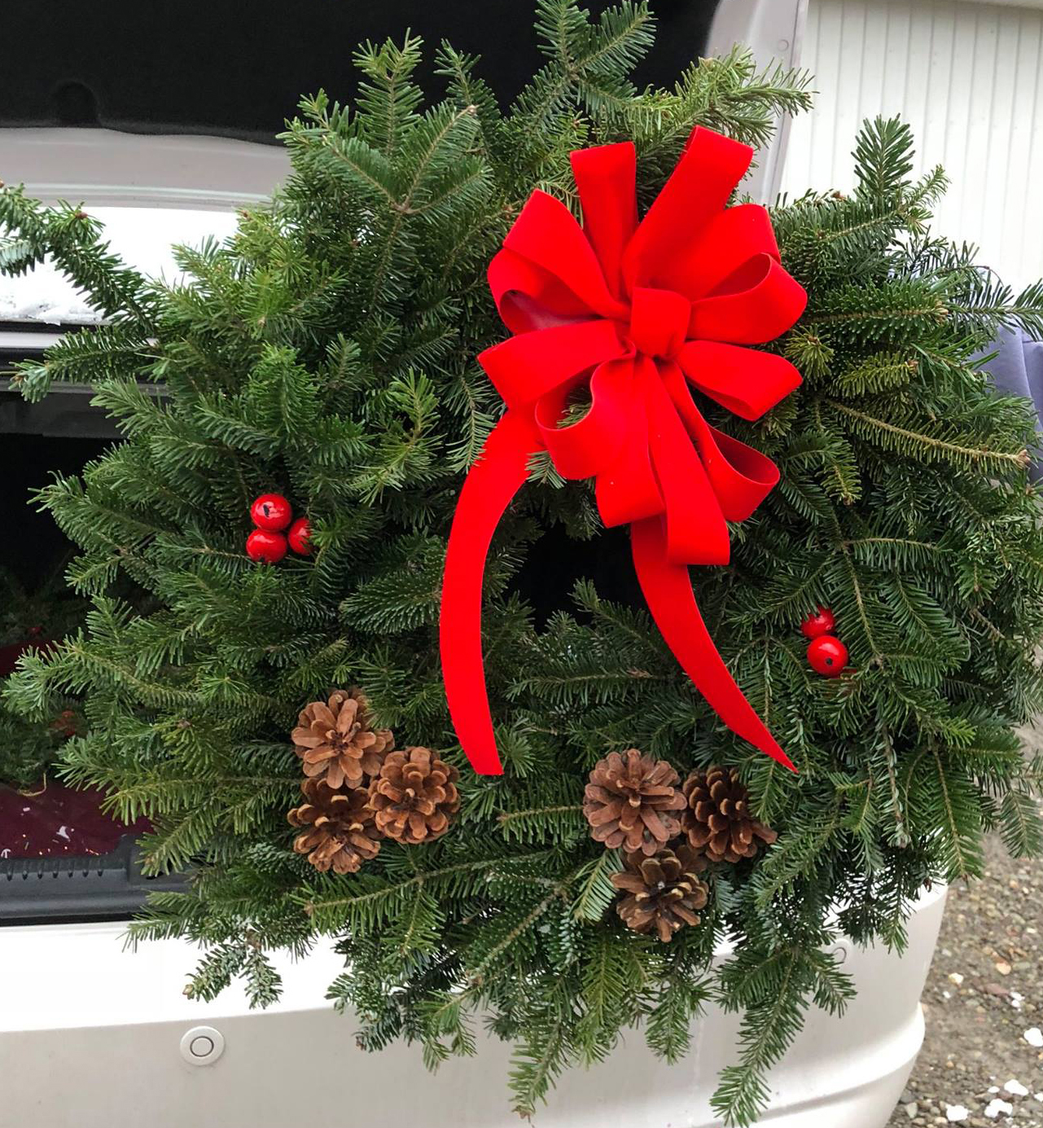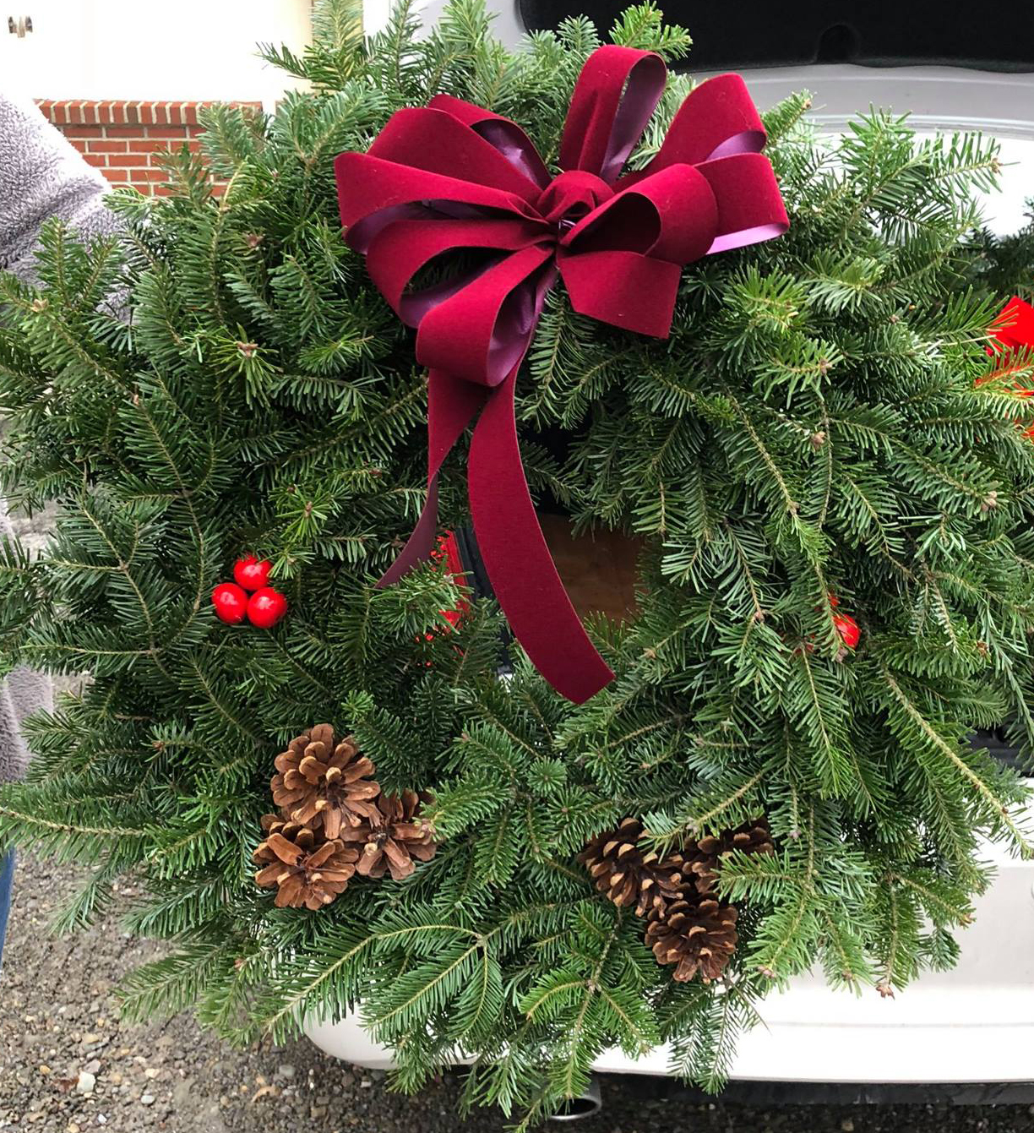

**2022 Wreath Order Form**

Wreaths with Red or Burgundy are $25 each

Wreaths with Gold Bows are $30 each

­­

I would like to order Christmas Wreaths as follows:

Wreaths with Red Ribbon _____# Total Number of Wreaths: _________

Wreaths with Burgundy Ribbon _____#

Wreaths with Gold Bows ______# Total Amount Enclosed: $_________

**Name __________________________________­­­­­____ Tel: __________________________**

**Email** (if available) _____________________________________to use for future wreath sales.

Return this form and payment to: Wreaths may be picked up at the

NUNDA HISTORICAL SOCIETY, Society Museum at 24 Portage St.,

BOX 341, NUNDA, NY 14517- 0341 9 am – Noon. on Saturday, Dec. 3rd

If you have questions, Call Fran Ludwig at 585-476-2749

You may also order wreaths from Fran and send payment to the above address.